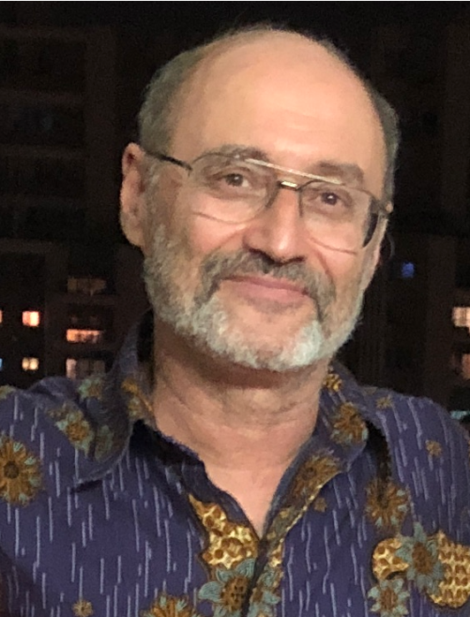
Dr. Garik Gutman is Program Manager for the NASA Land-Cover/Land-Use Change (LCLUC) Program (http://lcluc.hq.nasa.gov). He received his Ph.D. in Climate Modeling in 1984, was a National Research Council of the National Academy of Sciences Fellow at National Oceanic and Atmospheric Administration (NOAA), where he conducted research with satellite data for 14 years. His research focused on satellite remote sensing of the Earth's land surface and atmosphere. During mid-1990’s, Dr. Gutman played an active role in developing the Pathfinder global land time-series dataset from Advanced Very High-Resolution Radiometer (AVHRR). In 1996, for developing an original technique using satellite data for reliable analyses of the Earth’s vegetation cover and its long-term variations Dr. Gutman received the U.S. Department of Commerce Bronze Medal Award. He joined NASA in 1999 as the Land-Cover/Land-Use Cover Program Manager at NASA Headquarters and has been leading this program as well as Landsat-related activities at NASA.

He is author of over 80 publications in peer-reviewed scientific journals and of several chapters in various climate and land-cover related scientific books. Dr. Gutman was the Chief Editor of a compiled book “Land Change Science” published in 2004 based on the results of the projects supported by the NASA LCLUC Program during the first 8 years of the program. He has been a lead or co-editor on several books on LCLUC-climate interactions published by Springer: in the Eurasian Arctic, Siberia, Eastern Europe, and Central Asia. He serves as Editorial Board member in two open access MDPI journals: Remote Sensing and Land.

Dr. Gutman’s current research interests include the use of remote sensing for detecting changes in land cover and land use using multi-source land imaging approaches, including mid-resolution (Landsat-like) and very high-resolution commercial data, and analyzing the impacts of these changes on environment and society. The LCLUC research program helps to develop the underpinning science and promotes scientific international cooperation through supporting the development of regional science networks over the globe under the Global Observations of Forest Cover and Land Dynamics (GOFC-GOLD) international program, which the LCLUC Program has been supporting over more than two decades. Dr. Gutman has been playing a key role in building large multi-agency, international programs: Northern Eurasia Earth Science Partnership Initiative (NEESPI), and Monsoon Asia Integrated Regional Initiative (MAIRS), both under the International Geosphere-Biosphere Programme (IGBP) and the World Climate Research Programme (WCRP). Previously, the LCLUC Program supported the Large-Scale Biosphere Atmosphere Experiment in Amazonia (LBA) and, more recently, Dr. Gutman initiated and has been supporting the South/Southeast Asia Research Initiative (SARI). During several year, he represented NASA in Committee on Earth Observation Satellites (CEOS) Working Groups. For his international activities, Dr. Gutman received the NASA Outreach Award.

In his position at NASA HQ, Dr. Gutman has been Program Scientist for Landsat and Terra missions and was Program Scientist for EO-1 mission until its end. At the national level, Dr. Gutman chaired the US Global Change Research Program (USGCRP) Land-Use/Land-Cover Change Working Group for two years. He has collaborated with United States Geological Survey (USGS) on Landsat-related activities and co-led the NASA-USGS Global Land Survey initiative directed at developing global land mosaics every 5 years at Landsat spatial (30m) resolution before Landsat data became available free of charge. In recent years, Dr. Gutman has been leading the NASA-ESA Multi-Source Land Imaging (MuSLI) collaborative program consisting of projects based on synergistic use of Landsat and Sentinel-1 and -2 observations. Recently, he led the NASA Pilot Project in assessing the value of very high-resolution commercial data for NASA research and applications. Dr. Gutman is a member of the American Geophysical Union and Committee for Space Research (COSPAR) subcommittee A.

